FCU Fact Sheet - 2022/2023
Contact
Office | ☖: | Administrative Building II,  Room 304 No. 100, Wenhwa Rd.,  Seatwen Dist,  Taichung, Taiwan 40724, R.O.C.
 | ☏: | +886 4 2457 7520 ext. 2501
 | ✉: | oia@fcu.edu.tw
Coordinators | Inbound—Mr. Andy Yang
 | ☏: | +886 4 2457 7520 ext. 2507
 | ✉: | sxyang@fcu.edu.tw
 | Outbound—Ms. Valerie Sun
 | ☏: | +886 4 2457 7520 ext. 2506
 | ✉: | tsun@fcu.edu.tw
Website | https://oia.fcu.edu.tw/en/overseas-students/  *Please note that website includes the most recent information
Academic Calendar- Click and check FCU Calendar
 | Fall semester / Spring semester
Orientation week | September 9, 2022 |  | February 11, 2023
Semester term | September 12, 2022  ~January 13, 2023 |  | February 14, 2023  ~June 17, 2023
Examination week | January 11~13, 2023 |  | June 15~17, 2023
Vacation term | January 14, 2023  ~February 13, 2023 |  | June 18, 2023  ~September, 2023
Application Procedure
Step | Description |  | Fall / Spring
1.Nominate | Home university nominates students before deadline. |  | March 31, 2022  September 30, 2023
2.Apply | Students sends application documents to home university before deadline. |  | April 30, 2022  October 31, 2023
3.Submit | Home university submits application before deadline.
4.Review | FCU reviews application. |  | May / November
5.Accept | FCU mails acceptance packet to home university. |  | June / December
Requirements
Academic | GPA 2.8↑
Language | For English-taught Courses:  TOEFL iBT 70 / TOEFL itp 500 / TOEIC 700 / IELTS 4.5  *TOEIC 750 for master degree in business college  For Chinese-taught Courses:  HSK Level 6 / TOCFL Level 5
Application Documents
- One completed application form with ID photo & an approval stamp or signatures from home university
- Official academic transcripts
- Study plan + course pre-selection form (Appendix 1)
* Study Plan: briefly describe your motivation and short-term plan in FCU.
* Course pre-selection form: Check Information-courses
- A copy of a non-Taiwanese passport
- ID photo (for future student card)
Please combine (1)~(4) in a PDF file, and make (5) in a JPG file.
Information
Courses | Regular Courses:  1. Click the link of Course Search System  2. Find English Courses List  *Choose last year, courses of this year will release later  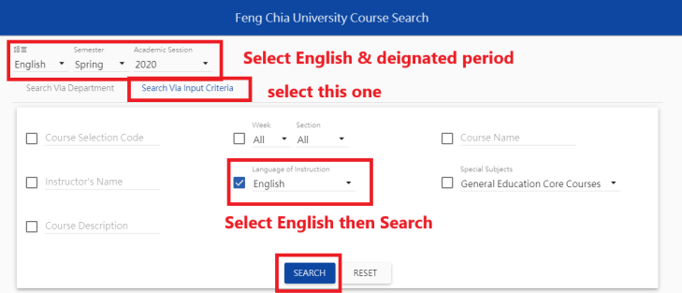  3. Record code on Course Pre-selection form  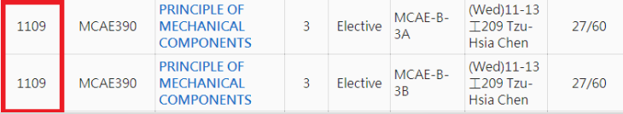  4. Basic Information + Detailed Description  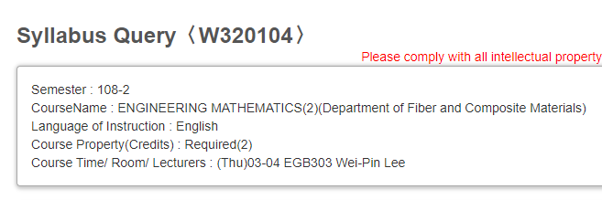  5. Register courses after arrival  Chinese Language Center:  Paid classes:  Chinese Language Center (CLC) is an individual institution in FCU campus. Students may apply Chinese class before your arrival (with tuition fees). For more information, check on CLC website!  Free classes:  It’s available if CLC has vacant seats. (we’ll confirm and release it 1 week after new semester)
Accommodation | No in-campus dorms available for short-term exchange/visiting students, please check the links for other alternative housing/accommodations：  http://www.liguan.com.tw/  https://www.formosalifeservices.com/  Average around NT$7,000-8,500 per month, plus deposit fee NT$10,000-15,000
VISA | FCU will issue an Acceptance Letter for students to apply VISA in home countries before arriving Taiwan. Students should apply different types of VISA (according to duration in TW, check info below) at the nearest Taipei Economic and Cultural Office (TECO) or embassies.  Visitor VISA  1-semester exchange  Complete Health Report (Form C)  Residence VISA  1-year exchange  Complete Health Report (Form B)  *Notice that health check for VISA is different from Campus health check.
Health Checks | All students need to do 2 health check (before& after arrival)  Before  Health check for VISA (see info at VISA part above)  After  Campus health check: FCU will arrange it for you, if you don’t submit a certificate of measles vaccine, you must do it in Taiwan.
Mandatory Expanse | Mandatory expanse in FCU: NT$4,250  International Medical insurance: NT$2,500  *5 months/one semester, not necessary if you have in your home country.  Student Card: NT$250  Accident Insurance & Computer Use: NT$950  Campus Health Check: NT$550  Living expanse  Refer to Living Cost Wstimator
Buddy System | Every exchange students will be assign with 1~2 volunteer students to assist.  *Students are not able to help accommodation contract.
Welcome Service | Our buddy group will help with airport pick-up, orientation and courses selection.
Transcripts | Electric transcript will be provided to both coordinator and students. Hard copy is available by request.

Appendix 1: Course Pre-Selection Form for
Incoming Exchange Students
Semester: 2022 Fall
Name:
Student ID: keep blank
*Please find your FCU student ID number from the admission letter
Course Number  選課代號  (4 digit number) | Course Title  科目名稱 | Time  時間 | Credits  學分數
(Add columns if you need more classes)

- Please pay attention to the class periods and avoid choosing classes that are scheduled at the same time. The course selection may be failed if the class time is clashed. The following table indicates the class periods we have.
- FCU has 3 phases of courses selection. This is the first period pre-selection. All courses are uncertain until the second phase starts. Please follow the Calendar of Course Selection.
Period | Time | Period | Time
01 | 08:10--09:00 | 08 | 15:10--16:00
02 | 09:10--10:00 | 09 | 16:10--17:00
03 | 10:10--11:00 | 10 | 17:10--18:00
04 | 11:10--12:00 | 11 | 18:10--19:00
05 | 12:10--13:00 | 12 | 19:10--20:00
06 | 13:10--14:00 | 13 | 20:10--21:00
07 | 14:10--15:00 | 14 | 21:10--22:00

